//MUHAMMAD AHMAD RAZA

//467253

//TASK 1

#include <iostream>

using namespace std;

int main(){

int arr[10];

int sum,avg=0;

for(int i=0;i<10;++i){

cout<<"enter integer for serial number "<<(i+1)<<": ";

cin>>arr[i];

}

cout<<"Entered integers are: ";

for (int i=0;i<10;++i){

cout<<arr[i]<<" ";

sum=sum+arr[i];

}

avg=sum/10;

cout<<endl;

cout<<"the average of the numbers in the array is: "<<avg;

}

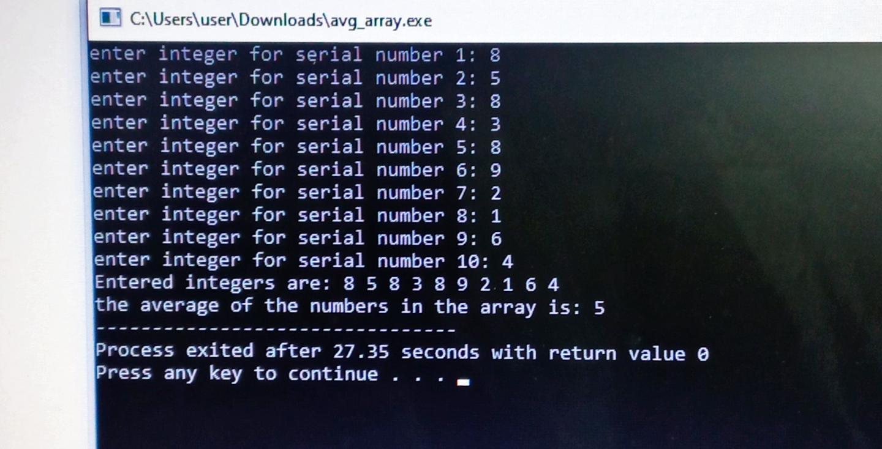

//TASK 2

#include <iostream>

using namespace std;

int main(){

int arr[5];

for(int i=0;i<5;++i){

cout<<"enter integer for serial number "<<(i+1)<<": ";

cin>>arr[i];

}

cout<<"original Array is: ";

for (int i=0;i<5;++i){

cout<<arr[i]<<" ";

}

cout<<endl;

for(int i=0;i<5-1;++i){

for(int j=0;j<5-i-1;++j){

if(arr[j]>arr[j+1]){

int temp=arr[j];

arr[j]=arr[j+1];

arr[j+1]=temp;

}

}

}

cout<<"array after sorting is: ";

for(int i=0;i<5;++i){

cout<<arr[i]<<" ";

}

cout<<endl;

}

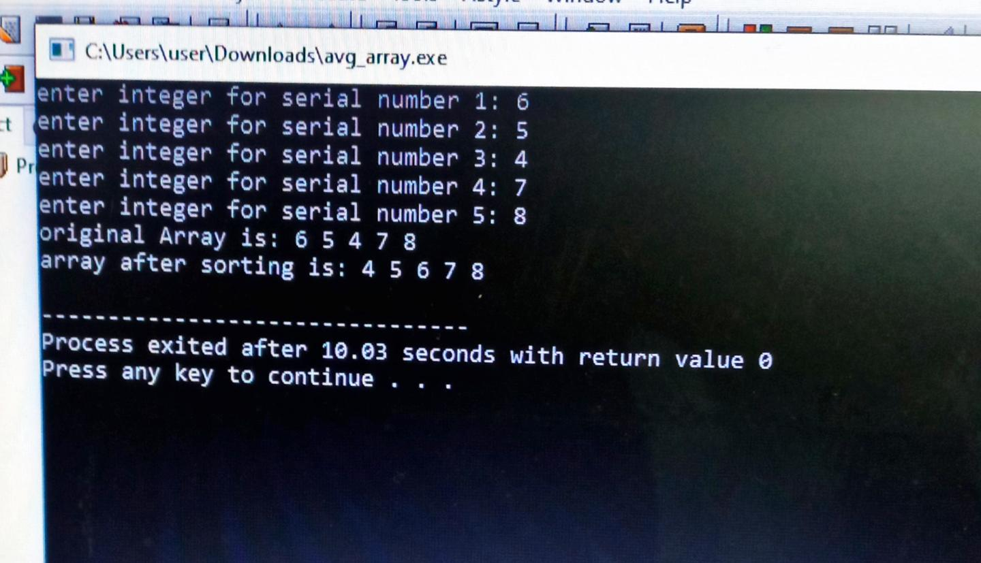

//TASK 3

#include <iostream>

using namespace std;

int main(){

double arr[10];

for(int i=0;i<10;++i){

cout<<"enter integer for serial number "<<(i+1)<<": ";

cin>>arr[i];

}

cout<<endl;

cout<<"Entered integers are: ";

for (int i=0;i<10;++i){

cout<<arr[i]<<" ";

}

int n=10;

double temp;

int m;

for (int k=0; k<=n-2;++k){

m=k;

for (int j=k+1;j<n; ++j){

if (arr[j]<arr[m]){

m=j;

}

}

temp=arr[m];

arr[m]=arr[k];

arr[k]=temp;

}

cout<<endl<<endl;

cout<<"array after sorting is: ";

for(int i=0;i<10;++i){

cout<<arr[i]<<" ";

}

cout<<endl;

}

